**NAME: MANI SAI MENDA**

**REG NO.:192111399**

**COURSE: DATABASE MANAGEMENT SYSTEMS FOR DATA ANALYTICS.**

**COURSE CODE: CSA0520.**

**Ex. No. : 5**

**SELECT with various clause – BETWEEN, IN, Aggregate function**

**QUESTIONS:**

**IN & B ETWEEN**

1)List the type of the courses “Statistics” and “Programming”

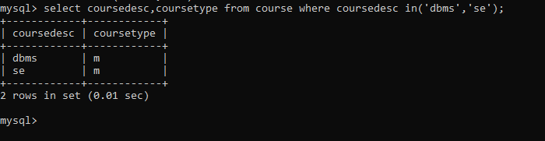

2)The instructor wants to know the CourseNos whose scores are in the range 50

to 80

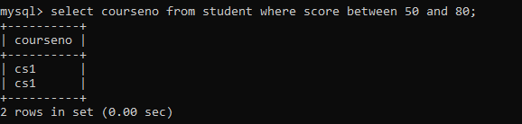

**AGGREGATE**

1.Find the average mark of “Cs2”.

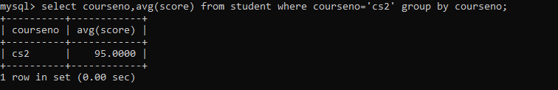

2.List the maximum, minimum mark for courses

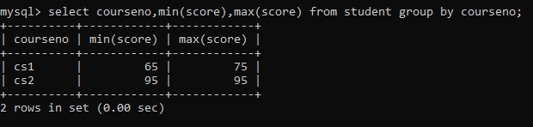

3.List the no of faculties in each department

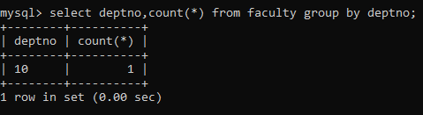

4.List the name of the courses and average mark of each courses.

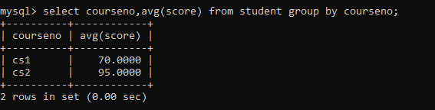

5.Calculate the sum of all the scores.

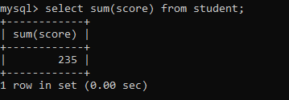

6.How many students are registered for each course? Display the

course description and the number of students registered in each course.

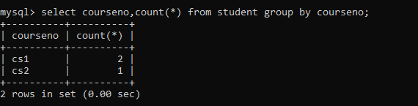

7.Display the sum of salaries in each department.

